1. Open the ENGREWORK workbook that you wish to import data to
2. Excel “Revamp” Sheet needs to be formatted with the data in these columns. (This should be how it comes in)

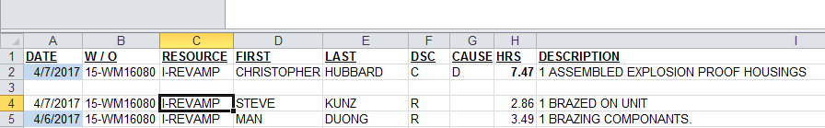

1. Right Click up top to customize the ribbon and Enable the developer option

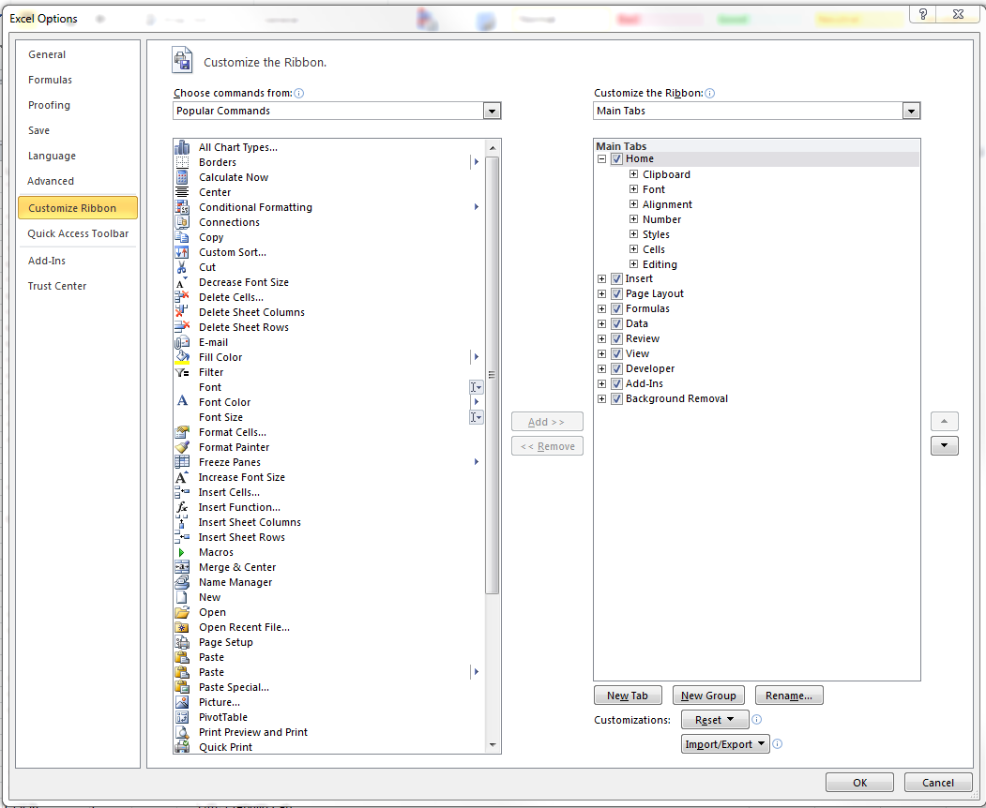

1. Select the Developer Tab on top and click Visual Basic

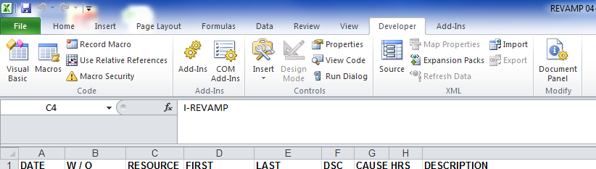

1. Drag the code in to your file

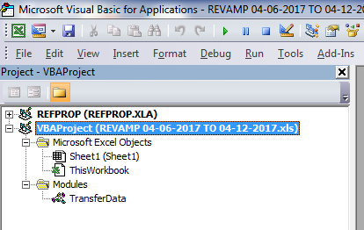

1. Click the “X” in the top corner to exit Visual Basic
2. Select/Highlight all the items you wish to export in Column A
   1. In the example below only the jobs before 16-PP16161 would be imported. The program can take as many jobs as you have so feel free to import all customs at once

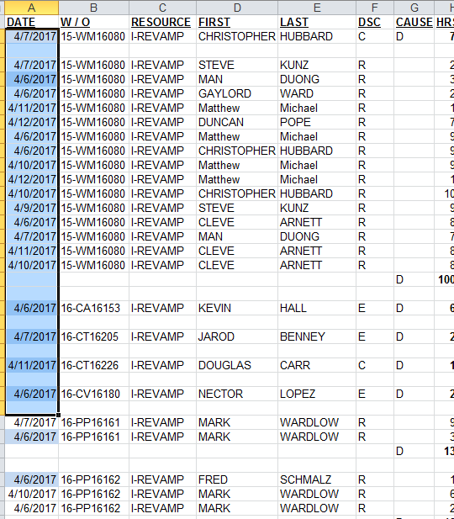

1. Run Program by selecting Macros => transfer_data=>Run

